

**COAL LAB PROJECT**

**TIC-TAC-TOE GAME**

**Lab Teacher: Sir Zakir Hussain**

**Syed Hadi Arshad K21-3326**

**Shaharyar Shahid K21-3443**

**Zayn Afaq K21-3414**

## Table Of Contents

1. Project Introduction 2

2. Working and Explanation 3

3. How Program Works 4

3.1 Player vs Player 5

3.2 Player vs Computer 6

3.3 Computer vs Computer 7

4. Methods Used 8

5. Limitations 9

6. Future Plans 9

7. Conclusion 9

8. References 9

# 1. Project Introduction

Our project is Tic-Tac-Toe game. This game is very popular and is simple by itself. It is a two-player game. In this game, there is a board with *n* x *n* squares. In our game, it is 3 x 3 squares. The goal of Tic-Tac-Toe is to be one of the players to get three same symbols in a row - horizontally, vertically, or diagonally.

The game is played on a 3 x 3 grid, as shown below.

The game can be played by two players. There are two options for players:

1. Human.
2. Computer

# 2. Working and Explanation

The players are assigned two symbols each, usual games use “X”and “O”. The first player is assigned “X” and the second player to is assigned “O”.

A player marks any of the 3x3 squares with his symbol (may be “X” or “O”) and his aim is to create a straight line horizontally or vertically or diagonally with two intensions:

1. Create a straight line before his opponent to win the game.
2. Restrict his opponent from creating a straight line first.

In case logically no one can create a straight line with his own symbol, the game results a tie.

Hence there are only three possible results – a player wins, his opponent (human or computer) wins or it’s a tie.

|  |  |  |
| --- | --- | --- |
| **1** | **2** | **3** |
| **4** | **5** | **6** |
| **7** | **8** | **9** |

If any player can draw three Xs or three Os in the following combinations, then that player wins. The combinations are:

a) 1, 2, 3 b) 4, 5, 6 c) 7, 8, 9 d) 1, 4, 7

e) 2, 5, 8 f) 3, 6, 9 g) 1, 5, 9 f) 3, 7, 5

# 3. How Program Works

The program consist of three modes

1. Player vs player
2. Player vs computer
3. Computer vs computer

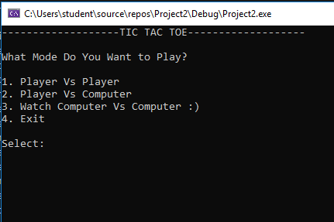

Main Menu

# Player vs Player

Asking player 1 to make move.

Asking player 2 to make move.

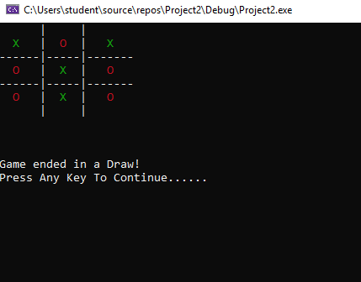

Final results

# Player vs Computer

In this mode computer is auto generating turn while user enter its choice

# Computer vs Computer

This mode generates move for both turn

# 4. Methods Used

1. PVP PROC
   1. This function starts the process of player-to-player game.
2. PVC PROC
   1. This function starts the process of player-to-computer game.
3. ComputerRandom PROC
   1. This functions randomly places a move when its computer’s turn.
4. CVC PROC
   1. This function starts the process of computer-to-computer game.
5. CVCRandom PROC
   1. This function places randon values for both turns as its computer vs computer.
6. GetMove PROC
   1. This function takes a mobe for every turn in the game.
7. makeMove PROC
   1. this function places move according to entered values of user.
8. checkDraw PROC
   1. this function check if the match is drawn after every turn.
9. checkWin PROC
   1. this function check after every turn if there is any winner.
10. initializesBoard PROC
    1. this function initializes the block with move number so that user knows which place is empty and where to place a move.
11. ColorWrite PROC
    1. This funtions colors the character to be places in the block to differentiate between users moves and to know which moves are available.
12. DisplayGame PROC
    1. This function displays the entire block after every placed move.

# 5. Limitations

1. It is a console-based Program, so for someone who has never used CLI, it can be very confusing.
2. Only the keyboard interface is implemented, the mouse is not activated in the game.

# 6. Future Plans

1. To implement GUI to make the application more attractive
2. We want to design more complex boards for the game in the future.
3. We want to add filing to store wins and loses so that tournaments can be made in the game

# 7. Conclusion

The Tic Tac Toe game is most familiar among all age groups. Intelligence can be the property of any purpose-driven decision-maker. This basic idea has been suggested many times. An algorithm for playing Tic Tac Toe has been presented and tested that works in an efficient way. Overall, the system works without any bugs.

# 8. References

1. <https://www.conceptispuzzles.com/index.aspx?uri=puzzle/tic-tac-logic>
2. <https://www.geeksforgeeks.org/implementation-of-tic-tac-toe-game/>
3. <https://www.neverstopbuilding.com/blog/minimax>